# Software Requirements Specification (SRS) for Skill Sync

1. Introduction

SkillSync is a web-based platform designed to seamlessly connect employers with skilled houseworkers, revolutionizing the unorganized sector. This Software Requirements Specification outlines the functional and non-functional requirements for the development and implementation of SkillSync.

2. Functional Requirements

2.1 User Registration and Authentication

Users should be able to register on the platform, providing necessary details.

Implement a secure authentication system to ensure user data privacy.

2.2 Employer Features

Employers should be able to create and manage job postings.

A location-based shortlisting mechanism should optimize employer searches for skilled houseworkers.

Provide a user-friendly interface for employers to interact with the platform seamlessly.

2.3 Skilled Houseworker Features

Skilled houseworkers must have the option to work independently or through a mediator.

Implement a profile showcase feature for skilled workers to display their expertise.

Provide an interface for skilled workers to manage their availability and work preferences.

2.4 Intermediary Module

Develop a specialized module for intermediaries to connect individuals with job opportunities, including collaboration with NGOs.

Ensure flexibility for intermediaries to efficiently engage with the platform.

2.5 Security and Verification

Employ comprehensive security measures for user data protection.

Implement verification processes for both employers and skilled workers.

2.6 Job Opportunity Generation

The platform should actively contribute to the generation of job opportunities for skilled houseworkers.

Facilitate economic stability and financial empowerment for skilled workers.

2.7 Collaboration and Partnerships

Foster collaboration and partnerships between employers and skilled houseworkers.

Create a network that benefits both parties, contributing to overall sector growth.

2.8 Measurement and Evaluation

Implement mechanisms to measure and evaluate the socioeconomic impact of SkillSync.

Continually assess how the platform contributes to the well-being and economic development of the housework sector.

3. Non-Functional Requirements

3.1 Performance

Ensure the platform can handle a scalable number of users.

Response time for user interactions should be minimal.

3.2 Reliability

The system should be available and reliable 24/7, with minimal downtime.

Implement backup and recovery mechanisms to safeguard against data loss.

3.3 Security

Employ encryption for data transmission.

Regularly update security protocols to protect against potential threats.

3.4 Usability

Provide a user-friendly interface for both employers and skilled workers.

Ensure the platform is accessible and easy to navigate.

3.5 Compatibility

SkillSync should be compatible with major web browsers and devices.

Ensure compatibility with various operating systems.

3.6 Innovation and Evolution

Commit to ongoing innovation in both technology and service offerings.

Stay abreast of industry trends to keep SkillSync at the forefront of the evolving housework sector.

4. Conclusion

This Software Requirements Specification outlines the essential features and characteristics of SkillSync. It serves as a guideline for the development team to ensure the successful implementation of a platform that connects employers and skilled houseworkers seamlessly, fostering economic growth and empowerment in the unorganized sector.

CONCEPTUAL MODELS

Data Flow Diagrams

## Level 0:

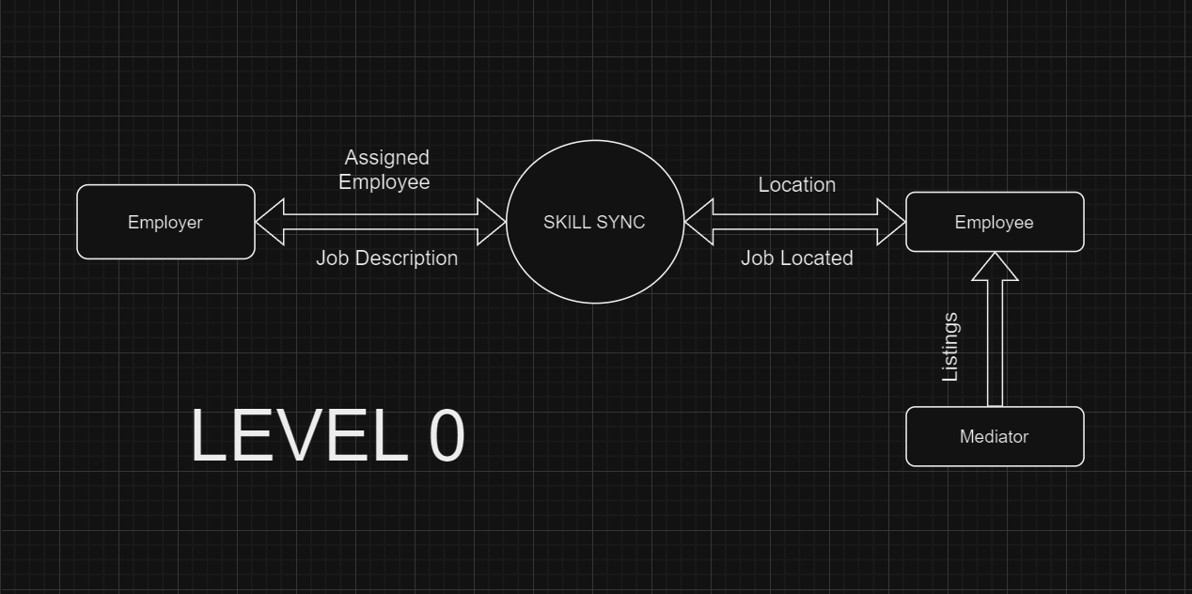

## Level 1:

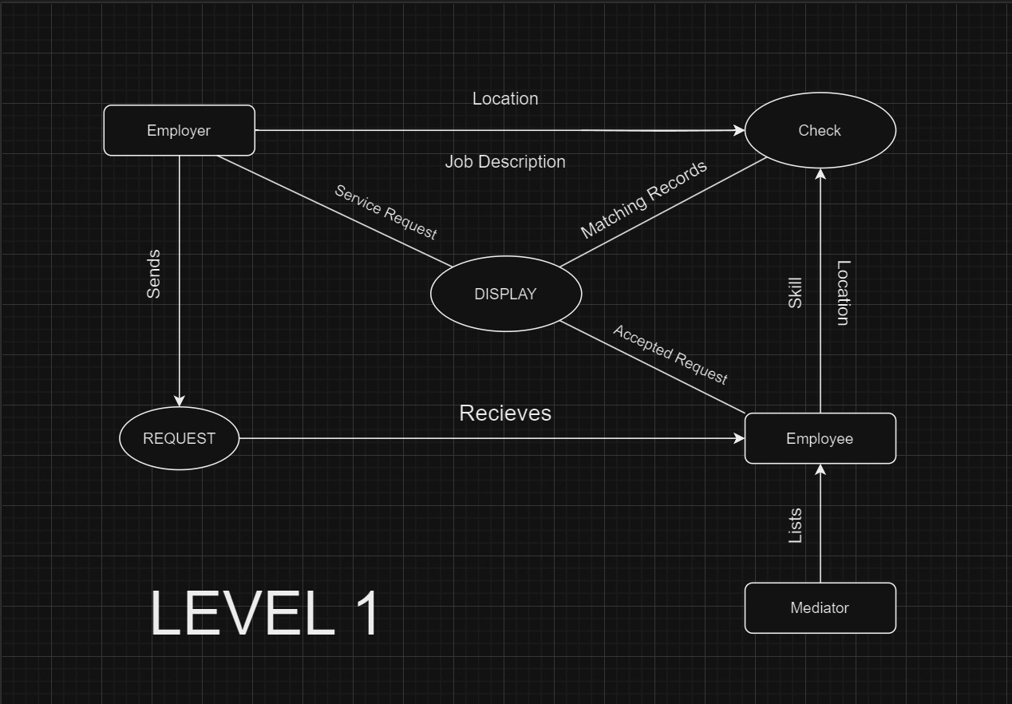

Proposed Tools :

For Front End : CSS , Adobe Dreamweaver , Photoshop , Adobe Firefly

For Backend : HeidiSql , MySql , Php

API Inegration : Google Maps

# ER DIAGRAM:

